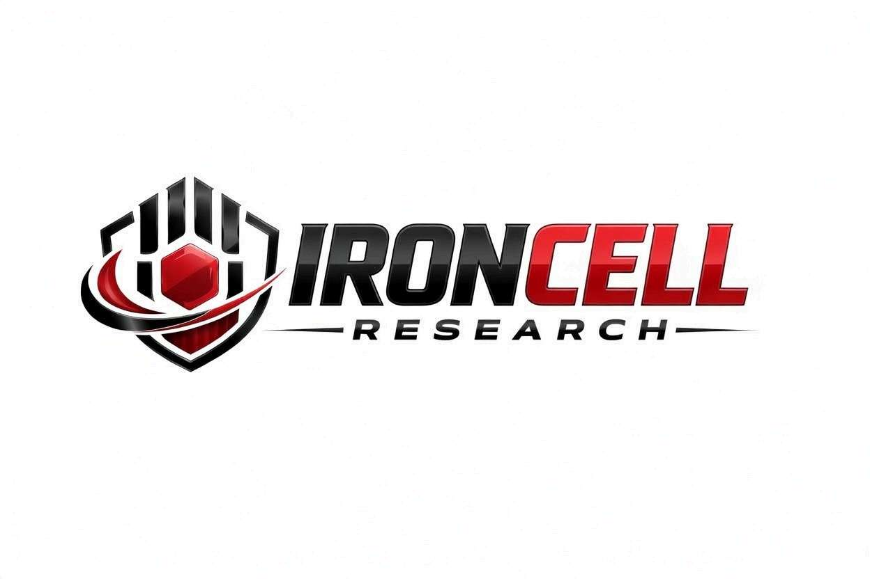
PEPTIDE RESEARCH BRIEF
5-Amino 1MQ
NNMT Inhibitor | Small Molecule Metabolic Research Compound

Description, Benefits, Dosage & Research Overview

Iron Cell Research
IronCellResearch.com
For Research Use Only


Compound Overview
Compound Name | 5-Amino 1MQ
Classification | Nicotinamide N-Methyltransferase (NNMT) Inhibitor · Metabolic Research
Amino Acid Sequence | Synthetic small molecule (non-peptide)
Molecular Formula | C10H11IN2
Molecular Weight | 286.12 g/mol
CAS Number | 19706-81-3
Biological Half-Life | Approximately 2-4 hours (preclinical models)
Purity | Greater than or equal to 99%
Storage | Lyophilized powder, -20C, protected from light
Research Status | Active preclinical research; no clinical trials to date

Description
5-Amino 1MQ (5-Amino-1-Methylquinolinium iodide) is a small-molecule research inhibitor of nicotinamide N-methyltransferase (NNMT), an enzyme implicated in cellular metabolism, NAD+ regulation, and adipose tissue dysfunction. NNMT is overexpressed in obesity and metabolic disease, where its activity consumes nicotinamide (a NAD+ precursor) and S-adenosylmethionine (SAM) — depleting cellular cofactor pools and reducing cellular energy expenditure.
By selectively inhibiting NNMT, 5-Amino 1MQ allows preservation of cellular NAD+ and SAM pools, restoring nicotinamide salvage and methylation capacity. In preclinical research it has been associated with reductions in adipocyte size, decreased fat mass without changes in caloric intake, and improvements in glucose handling and insulin sensitivity in diet-induced obese mouse models.
Studied as a tool compound for investigating NNMT-mediated metabolism, adipocyte energetics, and the cofactor-methylation axis, 5-Amino 1MQ provides researchers with a means to probe NNMT's role in metabolic homeostasis. For research use only — not for human consumption.

Mechanism of Action

NNMT Inhibition
5-Amino 1MQ binds the active site of NNMT as a substrate analog, competitively inhibiting its methyltransfer activity. This blocks conversion of nicotinamide to 1-methylnicotinamide (1-MNA) and prevents consumption of S-adenosylmethionine, preserving both cofactor pools for downstream metabolic and methylation pathways.

NAD+ & SAM Preservation
By blocking NNMT-mediated nicotinamide methylation, 5-Amino 1MQ preserves the nicotinamide pool available for NAD+ salvage. This sustains cellular NAD+ levels and supports SAM-dependent methylation reactions, indirectly reinforcing sirtuin activity and one-carbon metabolism.

Adipocyte Metabolism
NNMT inhibition shifts adipocyte energy use, increasing futile cycling of cofactors and basal energy expenditure. In white adipose tissue this manifests as smaller adipocyte size, reduced fat mass, and improved metabolic profile in obese rodent models — without altered food intake.

Methylation Capacity
Preservation of SAM via NNMT inhibition supports the broader methyltransferase landscape, including DNA, histone, and protein methylation. This connects NNMT activity to epigenetic regulation and cellular signaling beyond NAD+ metabolism.

Research Benefits

Body Composition & Adipose Health
- Adiposity Reduction: Reductions in fat mass observed in diet-induced obese mouse models without changes in caloric intake.
- Adipocyte Size: Decreased adipocyte hypertrophy with NNMT inhibition in white adipose tissue.
- Lean Mass: Preservation of skeletal muscle mass with selective adipose-targeted metabolic shifts.
- Energy Expenditure: Increased resting energy expenditure in metabolic chamber studies on obese rodents.

Metabolic Health
- Sedentary Models: Improved glucose tolerance and reduced fasting insulin in obese mouse models with NNMT inhibition.
- Lipid Profile: Reductions in circulating triglycerides and hepatic lipid content in preclinical obesity models.
- Hepatic Metabolism: Decreased hepatic steatosis and improved fatty acid oxidation in liver tissue.

Cellular Energy & NAD+
- NAD+ Levels: Preservation of cellular NAD+ pools by sparing nicotinamide from N-methylation.
- Lean Mass: Indirect support of sirtuin-dependent deacetylation through sustained NAD+ availability.
- Energy Expenditure: Enhanced mitochondrial substrate utilization in NNMT-inhibited cells.

Methylation & One-Carbon Metabolism
- SAM Preservation: Reduced SAM consumption via NNMT inhibition, supporting the activity of downstream methyltransferases.
- Methylation Balance: Studied for impact on histone and DNA methylation in metabolic tissues.
- Homocysteine Pathway: NNMT inhibition may shift methionine cycle dynamics and homocysteine flux; an active area of methyl-pool research.

Aging & Healthspan
- Mitochondrial Aging: NAD+ preservation has been studied for relevance to mitochondrial aging and senescence pathways.
- Sarcopenia Models: Investigated as part of metabolic interventions in aged or compromised muscle research.
- Healthspan Markers: Adipose-targeted metabolic shifts of interest in healthspan and obesity-related aging research.

Metabolic Health
- Sedentary Models: Studied in models of physical inactivity to dissect NNMT's role in obesity and metabolic dysfunction.
- Combination Studies: Used alongside other metabolic interventions to clarify NNMT-specific contributions.

Dosage & Administration
The following dosage information is provided for research reference purposes only. 5-Amino 1MQ is for laboratory research use only and is not intended for human consumption.
Protocol | Dose Range | Route | Frequency
Low / Introductory | 100-250 mcg | Per Protocol | Once daily
Standard | 250-500 mcg | Per Protocol | Once daily
Advanced | 500-1000 mcg | Per Protocol | Once daily
Preclinical Reference | 5-20 mg/kg | Oral / IP | Mouse studies, oral or IP

Reconstitution Guidelines
Solvent | Sterile bacteriostatic water
Reconstitution | 2-5 mL BAC water per 10mg vial (yields 2-5 mg/mL)
Mixing | Gently invert until dissolved; protocols may also use DMSO/PEG for IP delivery
Storage | Refrigerate at 2-8C, use within 21 days
Injection Site | Per institutional protocol (commonly IP in rodent studies)
Timing | Per protocol; published studies typically dose once daily

Safety Profile
5-Amino 1MQ has demonstrated a favorable safety profile in preclinical research:
- General Tolerability: Well tolerated in rodent studies at therapeutic research doses (e.g., 5-20 mg/kg IP) over multi-week regimens.
- Injection Site: Local reactions possible with IP or subcutaneous administration; rotate sites and use sterile technique.
- Cardiovascular: No significant cardiotoxicity reported at preclinical research doses.
- Hepatic / Renal: Limited hepatotoxicity or nephrotoxicity reported at preclinical research doses; further study ongoing.
- Drug Interactions: Limited interaction data; caution with other NAD+- or methyl-donor-modulating compounds.
- Pregnancy & Nursing: No human safety data; not for human consumption. 5-Amino 1MQ is supplied strictly for laboratory research use.

Key References
- Kraus D, Yang Q, Kong D, et al. Nicotinamide N-methyltransferase knockdown protects against diet-induced obesity. Nature. 2014;508(7495):258-262.
- Hong S, Moreno-Navarrete JM, Wei X, et al. Nicotinamide N-methyltransferase regulates hepatic nutrient metabolism through Sirt1 protein stabilization. Nature Medicine. 2015;21(8):887-894.
- Neelakantan H, Vance V, Wetzel MD, et al. Selective and membrane-permeable small molecule inhibitors of nicotinamide N-methyltransferase reverse high fat diet-induced obesity in mice. Biochemical Pharmacology. 2018;147:141-152.
- Kannt A, Rajagopal S, Kadnur SV, et al. A small molecule inhibitor of nicotinamide N-methyltransferase for the treatment of metabolic disorders. Scientific Reports. 2018;8:3660.
- Pissios P. Nicotinamide N-Methyltransferase: More Than a Vitamin B3 Clearance Enzyme. Trends in Endocrinology & Metabolism. 2017;28(5):340-353.
- Komatsu M, Kanda T, Urai H, et al. NNMT activation can contribute to the development of fatty liver disease by modulating the NAD+ metabolism. Scientific Reports. 2018;8:8637.
- Roberti A, Fernández AF, Fraga MF. Nicotinamide N-methyltransferase: At the crossroads between cellular metabolism and epigenetic regulation. Molecular Metabolism. 2021;45:101165.

Contact & Information
Company | Iron Cell Research
Website | IronCellResearch.com
Email | orders@ironcellresearch.com
Product Support | Available via website contact form

Disclaimer
This document is intended for informational and research purposes only. 5-Amino 1MQ is sold strictly as a research compound and is not intended for human consumption. The information provided herein does not constitute medical advice, diagnosis, or treatment recommendations. All research applications should comply with applicable institutional, local, and federal regulations. Iron Cell Research makes no claims regarding the therapeutic efficacy of 5-Amino 1MQ for any medical condition. Researchers should consult with qualified healthcare professionals and institutional review boards before initiating any research protocols involving human subjects.
Iron Cell Research - For Research Use Only


